Resume Analyzer Using Azure AI
Project Report
Version 1.2
Industrial Training (ECS599)
Degree
B.Tech(AI-ML-DL)

PROJECT GUIDE:  Project Guide Name (External):  Project Guide Name (Internal):  Mr. Nirpesh Sir | SUBMITTED BY:  Student Name: Bairla Yeshwanth  (Student ID): TCA2359055

December, 2025



FACULTY OF ENGINEERING & COMPUTING SCIENCES
TEERTHANKER MAHAVEER UNIVERSITY, MORADABAD

ACKNOWLEDGEMENT

Student Name: Bairla Yeshwanth
Place:
Date:

DECLARATION

We hereby declare that this Project Report titled __________________________________________ submitted by us and approved by our project guide, the College of Computing Sciences and Information Technology (CCSIT), Teerthanker Mahaveer University, Moradabad, is a bonafide work undertaken by us and it is not submitted to any other University or Institution for the award of any degree diploma / certificate or published any time before.

Project Group :
Student Name:
Project Guide: (External)
Project Guide: (Internal)

Brief About the Company

Edunet Foundation:
Edunet Foundation (EF) is a prominent India-based non-profit organization established in 2015 and headquartered in Gurgaon, Haryana. The foundation focuses on addressing the widening gap between academic learning and the evolving needs of the global industry. By equipping learners—especially youth from diverse socio-economic backgrounds—with employability skills, digital literacy, and advanced technology competencies, Edunet aims to create an inclusive and future-ready workforce. Its credibility is strengthened by its Special Consultative Status with the United Nations ECOSOC, recognizing its contributions to social development, digital empowerment, and youth upskilling at both national and international levels.

- 1. Mission & Vision
Edunet Foundation’s mission is to democratize access to high-quality education, digital resources, and future-skills training. The organization strives to ensure that every individual—regardless of gender, geography, or financial background—can unlock meaningful career and learning opportunities.
Its vision aligns with the needs of Industry 4.0 and Industry 5.0, emphasizing:
- Artificial Intelligence
- Cloud Computing
- Cybersecurity
- Data Analytics & Data Literacy
- Design Thinking
- Employability & Professional Skills
Edunet believes in fostering a generation of problem-solvers and innovators capable of contributing to a rapidly transforming digital economy.

- 2. Key Focus Areas
Edunet Foundation’s initiatives span across different learning ecosystems. Its programs are structured to meet learners at various stages of education and professional readiness.
- a) Schools (K–12 Ecosystem)
The foundation introduces students to STEM concepts, computational thinking, digital tools, and early exposure to emerging technologies. Programs include hands-on workshops, robotics, AI fundamentals, and innovation-centric activities, nurturing curiosity and preparing young minds for future academic pursuits.
- b) Colleges & Higher Education
3. Major Programs & Initiatives
Edunet Foundation runs several nationally recognized initiatives in partnership with leading global organizations:
A flagship program offering a robust digital learning platform for students, educators, and job seekers. It provides high-quality online training in:
- Artificial Intelligence
- Cloud Computing
- Cybersecurity
- Data Science
- Workplace Readiness
- Professional Skills (communication, teamwork, critical thinking)
:
- App development
- Design thinking
- Coding fundamentals
- AI & ML basics
- Startup and career readiness mentoring
- c) Skills4Future
A forward-looking program that focuses on sustainability, green jobs, environmental awareness, and developing workforce capabilities aligned with the emerging global green economy.
- Additional Initiatives Include:
- Teacher training programs
- Hackathons, innovation challenges, and bootcamps
- Digital literacy for rural and underserved communities
- Career counseling and mentorship sessions
4. Impact
- Online learning platforms
Its impact includes:
- Significant improvement in employability for college graduates
- Enhanced technical readiness for school students
- Increased digital inclusion among women and underserved communities
- Strong industry-academia collaboration for curriculum modernization
Overall, the foundation contributes to national development goals such as Digital India, Skill India, and inclusive socio-economic growth.
- 5. Partnership Model
Edunet Foundation’s partnership approach is collaborative, scalable, and sustainable. It works closely with:
- Government bodies
- Universities & educational institutions
- Global corporations
- NGOs and community organizations
- International development agencies

Table of Contents
1 Project Title 7
2 Problem Statement 7
3 Project Description 8
3.1 Scope of the Work 8
3.2 Project Modules 10
3.3 Context Diagram (High Level) 13
4 Implementation Methodology 14
5 Technologies to be used 16
5.1 Software Platform 16
5.2 Hardware Platform 16
5.3 Tools, if any 16
6 Advantages of this Project 17
7 Assumptions, if any 18
8 Future Scope and further enhancement of the Project 19
9 Project Repository Location 20
10 Definitions, Acronyms, and Abbreviations 21
11 Conclusion 22
12 References 24
Resume Table (RESUME) 28
Analysis Result Table (RESULT) 28

Appendix
A: Data Flow Diagram (DFD)
B: Entity Relationship Diagram (ERD)
C: Use Case Diagram (UCD)
D: Data Dictionary (DD)
E: Screen Shots

Project Title
Resume Analyzer Using Azure AI

Problem Statement
Recruiters and hiring teams receive a high volume of resumes in heterogeneous formats (PDF/DOCX/TXT) and layouts. Manual review is time-consuming, inconsistent, and prone to human bias and oversight—especially when screening for basic candidate information (name, contacts), core skills, education, and work experience across multiple applicants.
Traditional keyword-based filtering struggles with:
- Different resume templates and section titles (e.g., “Work History” vs “Professional Experience”).
- Noise and formatting artifacts in PDF/DOCX conversion.
- Partial/missing sections, inconsistent ordering, and sparse information.
- Difficulty extracting structured information (entities like organizations, locations, roles) from unstructured resume text.
Hence, there is a need for a web-based system that:
- accepts resumes in common formats,
- extracts reliable text and key fields,
- identifies important entities/skills via NER,
- summarizes extracted insights for quick screening,
- supports scalable, repeatable screening with reduced turnaround time.
This project addresses the above by building a Flask web application that uploads resumes and uses Azure AI Document Intelligence for document extraction and Azure AI Language (NER) to identify key entities

Project Description
Overview
Resume Analyser is a web application that enables users (recruiters or applicants) to upload a resume and obtain structured information such as:
- Candidate name and contact details
- Skills
- Education
- Experience
and additionally identify entities (e.g., organizations, locations) using NER.
The repository describes the system as an “AI-powered Resume Analyzer built with Python and Azure AI services” with a Flask web interface and resume upload supporting PDF/TXT/DOCX. GitHub
The project uses two key AI components:
- Azure AI Document Intelligence (formerly Form Recognizer) to extract text/structure from documents at scale (OCR + layout understanding + key-value extraction). GitHub+1
- Azure AI Language Named Entity Recognition (NER) to identify and classify named entities in unstructured text (people, organizations, locations, etc.). GitHub+1
The application is intended to support faster screening and reduce manual effort by converting resumes into normalized outputs.

Scope of the Work
3.1.1 In-Scope Functional Scope
- Resume Upload & Validation
  - Accept resume files in PDF, DOCX, and TXT formats. GitHub
  - Validate supported extensions and reject unsupported formats.
  - Store uploaded file (temporarily or persistently depending on deployment configuration).

- Document Text Extraction
  - Extract readable text and document structure using Azure Document Intelligence, which is designed to extract text, structure, and key-value pairs from documents using ML-based OCR and document understanding. Microsoft Learn
- Entity Extraction / NER
  - Perform NER on extracted text to identify entities like persons, organizations, locations, and other predefined categories. Microsoft Learn+1
- Key Resume Field Extraction
  - Extract typical resume metadata: name, contact information, skills, education, experience (as stated in repository feature list). GitHub
  - Present extracted information via a web UI.
- Result Presentation
  - Render extracted insights in HTML templates with basic formatting and sectioning.
  - Provide a readable summary useful for screening.
- Configuration via Environment Variables
  - Use environment variables for Azure service endpoints and keys (the repository documents AZURE_LANGUAGE_ENDPOINT and AZURE_LANGUAGE_KEY)

3.1.2 In-Scope Non-Functional Scope
- Security Basics
  - Keep keys in environment variables rather than hard-coding.
  - Use safe file upload handling patterns (Flask encourages use of secure_filename() since filenames can be forged). flask.palletsprojects.com+1
- Performance & Scalability (Entry-Level)
  - Responsive processing for single resume uploads.
  - Clear separation of web layer and analysis layer for maintainability.
- Maintainability
  - Modular separation between app entry point, analysis logic, and parsing logic (as implied by distinct files such as app.py, analyzer.py, resume_parser.py).

3.1.3 Out-of-Scope (Current Version)
(These are not claimed by the repository’s README; they are future candidates.)
- Multi-user authentication and role-based access control.
- Job description matching and ATS scoring.
- Bulk resume ingestion pipeline (batch processing).
- Recruiter dashboards, analytics, ranking, and exporting to CSV.
- Automated bias auditing / fairness measurement.
- Fine-tuned custom extraction model training pipeline (possible with Azure, but not specified as implemented). Microsoft Learn+1

Project Modules
Below is a modular decomposition suitable for documentation and implementation mapping.
Module 1: User Interface (Web Frontend)
Purpose: Provide an interface to upload resumes and view extracted results.
Key responsibilities:
- Upload form (file input).
- Result page rendering (structured fields + entity highlights).
- Display errors (unsupported format, missing keys, Azure failure).
Inputs: Resume file (PDF/DOCX/TXT).
Outputs: HTML pages displaying extracted data.
Module 2: Flask Application Layer (Controller/Routes)
Purpose: Orchestrate request handling and connect UI with backend analysis.
Key responsibilities:
- Routes: / (upload), /analyze (process), possibly /result.
- File saving and request validation.
- Trigger analysis functions and pass results to templates.
Security Considerations:
Flask’s upload pattern recommends sanitizing filenames using Werkzeug’s secure_filename() before saving. flask.palletsprojects.com+1

Module 3: Resume Parsing / Text Normalization
Purpose: Convert uploaded resumes into clean text for downstream AI steps.
Key responsibilities:
- Detect file format and apply relevant extraction method.
- Normalize whitespace, remove obvious artifacts, unify encoding.
- Produce canonical text stream for AI calls.
Outputs: Cleaned plain text.
Module 4: Azure Document Intelligence Extraction
Purpose: Extract text and structure from resumes reliably.
Azure Document Intelligence is a cloud service that applies ML-based OCR + document understanding to extract text, structure, and key/value pairs from documents. Microsoft Learn+1
Key responsibilities:
- Submit the resume file to Azure Document Intelligence.
- Poll asynchronous analysis if required (Azure analyze operations can be asynchronous and return a URL to poll). Microsoft Learn
- Parse response into usable text blocks and potential layout segments.
Module 5: Azure AI Language (NER)
Purpose: Identify and categorize named entities in extracted resume text.
Azure NER identifies and categorizes entities in unstructured text (person, place, organization, etc.). Microsoft Learn+1
Key responsibilities:
- Submit resume text to NER endpoint.
- Retrieve entity list and categories.
- Optionally map entities to resume fields (e.g., org names into “Experience” support data).
Module 6: Resume Field Extractor (Heuristics + NER-assisted)
Purpose: Produce final structured fields: name, contact, skills, education, experience.
Key responsibilities:
- Extract email/phone via regex patterns.
- Identify skill keywords using dictionaries / patterns (or a curated skill list).
- Segment text into sections using headings detection (e.g., “Education”, “Experience”, “Skills”).
- Use NER outputs to improve organization and location detection.
Module 7: Result Composer & Report Formatter
Purpose: Build an output object for UI rendering (and future exports).
Key responsibilities:
- Standardize final JSON-like structure:
  - candidate_name
  - contacts (email, phone, links)
  - skills
  - education
  - experience_summary
  - entities (NER list)
- Provide fallbacks if sections are missing.
Module 8: Deployment & Configuration
Purpose: Run consistently in local and hosted environments.
Repository mentions web deployment (README references deployment and a live site link). GitHub
Key responsibilities:
- Environment variable handling.
- WSGI readiness (Gunicorn for production typical).
- Static assets and templates packaging.

Context Diagram (High Level)
System Name: Resume Analyser (Web + AI Services)
External Entities:
- User (Recruiter/Applicant)
- Azure AI Document Intelligence Service
- Azure AI Language (NER) Service
- (Optional infrastructure) Deployment Platform / Web Host
High-Level Context Diagram (Text Form):
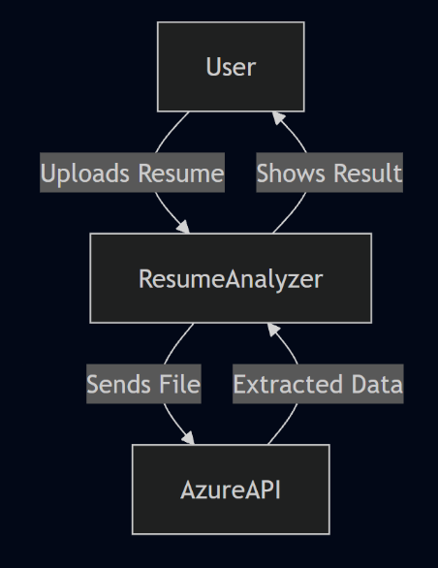

Implementation Methodology
Methodology Approach
A practical methodology for this project is Iterative / Incremental Development with continuous validation using sample resumes (the repository contains a test_resumes folder, indicating a test dataset concept). GitHub
The system can be implemented in increments:
Iteration 1: Core Web Upload + Local Parsing
- Create Flask app routes and templates.
- Implement file upload validation, secure storage approach.
- Confirm local extraction for TXT/DOCX (baseline).
Iteration 2: Azure Document Intelligence Integration
- Configure endpoint and keys via environment variables. GitHub
- Upload document bytes to Document Intelligence.
- Extract text from the response and normalize.
Azure Document Intelligence is designed to extract text, tables, structure, and key/value pairs; therefore it provides stronger extraction than naive PDF-to-text methods for many layouts. Microsoft Learn+1
Iteration 3: NER Integration and Entity Display
- Send cleaned text to Azure NER.
- Parse entities and categories; display as a list and/or highlighted tokens.
Azure NER identifies and categorizes entities like person, location, organization, etc. Microsoft Learn+1
Iteration 4: Resume Field Extraction Layer
- Add heuristics:
  - Email regex
  - Phone regex
  - Section header detection
  - Skills dictionary matching
- Improve reliability using NER outputs (orgs, locations).
Iteration 5: Error Handling + UI Improvements
- Clear errors for missing Azure keys, invalid files.
- Add loading state and better results page formatting.
Iteration 6: Production Deployment Readiness
- Add deployment configuration (Procfile/Gunicorn if applicable).
- Validate environment variables on host.
- Use a secure upload folder and clean-up policy.

Data Flow (Operational Steps)
- User opens the web application and selects a resume file. GitHub
- Flask receives the file via HTTP POST.
- System validates file type and stores it.
- System sends file to Azure Document Intelligence for extraction. Microsoft Learn+1
- Extracted text is normalized.
- Normalized text is sent to Azure NER for entity extraction. Microsoft Learn+1
- The system extracts key resume fields (name/contact/skills/education/experience).
- Results are composed and rendered in UI.
Security & Compliance Considerations (Implementation-Level)
- Secrets Management
  - Keep Azure keys in environment variables (repository explicitly expects keys in .env). GitHub
- File Upload Security
  - Filenames can be forged; sanitize with secure_filename() before saving. flask.palletsprojects.com+1
  - Restrict allowed extensions.
  - Limit maximum upload size in Flask config.

- PII Handling
  - Resumes contain PII (names, emails, phone numbers).
  - Consider data minimization and deletion policies.
  - Avoid logging raw resume content in production logs.
- Network Security
  - Use HTTPS in deployment.
  - Ensure Azure endpoints are accessed over TLS.

Technologies to be used

Software Platform
- Front-end: Flask (HTML, CSS, JavaScript)

- Back-end: Python, Azure AI Services

Hardware Platform
RAM: 8 GB
Hard Disk: 256 GB or higher
Operating System: Windows / Linux
Editor: Visual Studio Code
Browser: Chrome or Edge

Tools, if any
- Visual Studio Code (Microsoft, v1.90+)
- Azure Portal (Microsoft)
- Postman (v10+ for API Testing)

Advantages of this Project
The AI Powered Resume Analyser offers several significant advantages that address the limitations of traditional resume screening and recruitment processes. By integrating artificial intelligence and cloud-based services, the project enhances efficiency, accuracy, and consistency in resume analysis while reducing dependency on manual effort.
One of the primary advantages of this project is time efficiency. Manual resume screening is a slow and repetitive task, especially when handling large volumes of applications. The Resume Analyser automates the extraction and analysis of resume content, enabling results to be generated within seconds. This significantly reduces the overall recruitment cycle time and allows recruiters to focus on decision-making rather than data extraction.
Another major advantage is reduction of human effort and operational workload. The system minimizes the need for recruiters to manually read and interpret resumes by converting unstructured resume documents into structured and summarized information. This leads to improved productivity and optimal utilization of human resources.
The project also ensures consistency and standardization in resume evaluation. Human reviewers may apply subjective judgment or inconsistent criteria, whereas the AI-based system applies uniform analysis logic across all resumes. This standardization makes candidate comparison more objective and reliable.
Improved accuracy is another important advantage. The use of AI-based document intelligence allows accurate extraction of text even from resumes with complex layouts, tables, or varied formatting styles. Additionally, Named Entity Recognition improves contextual understanding by identifying important entities such as skills, organizations, and educational institutions.
The system provides scalability and flexibility, making it suitable for both small organizations and large enterprises. Since the application is cloud-based, it can handle increasing workloads without significant architectural changes. The modular design also allows easy integration of future features such as job description matching and resume ranking.
From a security perspective, the project follows secure data handling practices by validating uploaded files and managing sensitive configuration data through environment variables. This reduces the risk of data leakage and unauthorized access.
Finally, the Resume Analyser has strong academic and practical value. It demonstrates real-world application of artificial intelligence, natural language processing, cloud computing, and web development. The project serves as an effective learning tool while also providing a foundation for advanced recruitment automation systems.

Assumptions, if any
- Azure Services Availability
- Azure Document Intelligence and Azure NER endpoints are available and properly configured. Microsoft Learn+1
- Valid API Keys and Endpoints
- Environment variables are correctly set (repository expects Azure language endpoint and key). GitHub
- Resume Quality
- Uploaded resumes are readable and not heavily corrupted.
- Scanned PDFs are supported but quality may impact OCR accuracy.
- Language Assumption
- Resumes are primarily in English (or in a language supported by the configured Azure model). (Language support varies by Azure configuration; deployment should confirm supported languages.)
- User Intent
- Users upload resumes for legitimate screening/self-review, not for malicious file uploads.

Future Scope and further enhancement of the Project
The feature scope of the AI Powered Resume Analyser defines the complete set of functionalities provided by the system in its current implementation. It clearly outlines what the system is designed to perform, the services it delivers to users, and the boundaries within which it operates. The feature scope focuses on practical, real-world resume analysis requirements while maintaining simplicity, scalability, and accuracy.
The primary feature of the system is automated resume upload and analysis. The application allows users to upload resumes in commonly used formats such as PDF, DOCX, and TXT through a web-based interface. This feature eliminates the need for manual data entry and ensures ease of use for both recruiters and individual users. File validation mechanisms are included to ensure that only supported and safe document formats are processed.
Another key feature is intelligent document text extraction. The system utilizes cloud-based AI document processing to extract textual content from resumes, even when the document contains complex layouts such as multi-column text, tables, or inconsistent formatting. This ensures higher accuracy compared to traditional optical character recognition methods and enables reliable processing of resumes created using different templates.
The system also includes Named Entity Recognition (NER) as a core feature. Through this capability, the application identifies and classifies important entities such as candidate names, organizations, locations, and other relevant elements present in the resume text. This contextual understanding enhances the system’s ability to interpret resume content beyond simple keyword matching.
A major feature of the Resume Analyser is structured resume information extraction. The system extracts and organizes key resume components including personal details, contact information, skills, educational qualifications, and work experience. The extracted data is presented in a structured and readable format, making it easier for users to review and compare resumes efficiently.
The result visualization feature enables users to view analyzed resume data directly through the web interface. The system presents the extracted information in clearly defined sections, improving readability and supporting faster decision-making. Error messages and status updates are also displayed to guide users during file upload and analysis.

Project Repository Location
https://github.com/yeshu2006/resume-analyser
S# | Project Artifacts (softcopy) | Location  (Mention Lab-ID, Server ID, Folder Name etc.) | Verified by Project Guide | Verified by Lab In-Charge
 | Project Synopsis Report (Final Version)
 | Project Progress updates
 | Project Requirement specifications
 | Project Report (Final Version)
 | Test Repository
 | Any other document, give details

Definitions, Acronyms, and Abbreviations

Abbreviation | Description
AI | Artificial Intelligence – capability of machines to simulate human intelligence.
Azure Document Intelligence | A cloud-based document processing service by Microsoft Azure used for extracting structured data from documents. Formerly known as Form Recognizer.
API | Application Programming Interface – enables communication between the Resume Analyzer backend and Azure AI service
ATS | Applicant Tracking System – automated software used by recruiters to filter resumes based on keywords and structure.
OCR | Optical Character Recognition – technology used to extract text from documents, underlying Azure Resume Model
Flask | A Python-based micro web framework used to build the backend of the Resume Analyzer.
Frontend | The user interface where resume upload and results display takes place.
Backend | Server-side logic responsible for processing input, communicating with Azure AI, and returning results.
Output Module | Part of the system responsible for formatting and displaying extracted data to the user.
Deployment | Hosting the application on a live server (e.g., Render, Azure App Services).

Conclusion
The development of the Resume Analyzer Using Azure AI Text Analytics represents a significant step toward integrating artificial intelligence into the recruitment and skill assessment processes. With the rapid increase in job applications and the diversity of candidate profiles, traditional manual resume screening methods have become inefficient, inconsistent, and prone to human bias. This project demonstrates how cloud-based AI services can transform resume evaluation into a faster, more accurate, and data-driven process.
The implemented system successfully extracts text from PDF and DOCX files, identifies skills, experience lines, and key resume components, compares the extracted information against job descriptions, and computes a meaningful match percentage. Through the integration of Azure AI Text Analytics, the system leverages advanced linguistic intelligence such as key phrase extraction, named entity recognition, and contextual keyword analysis. These capabilities enable deeper insights into resume structure, content richness, and overall alignment with job expectations.
One of the major outcomes of this system is its ability to detect gaps in a candidate’s profile. Missing sections such as Skills, Education, Experience, Projects, or Certifications are highlighted clearly, providing valuable guidance for improving resume quality. Likewise, missing job keywords and relevant competencies are identified, helping job seekers align their resumes more closely with employer expectations. This feedback mechanism directly supports better career development, improved job readiness, and stronger application outcomes for candidates.
The project also proves the effectiveness and practicality of using Python Flask as a lightweight backend framework. The modular nature of the system—resume extraction, AI integration, matching logic, skill detection, and result generation—ensures flexibility, maintainability, and future expandability. The combination of cloud AI processing and a simple, intuitive web interface allows the system to be deployed in real-world environments, such as career portals, college placement cells, recruitment platforms, and HR automation tools.
The Resume Analyser project delivers a practical, web-based solution for automating resume data extraction and preliminary screening support. By combining a lightweight Flask application layer with Azure AI Document Intelligence for robust document extraction and Azure NER for entity identification, the system addresses a core recruitment bottleneck: transforming unstructured resumes into structured, review-friendly insights.
The repository’s feature set—uploading resumes, extracting candidate details, and applying named entity recognition—supports faster decision-making while maintaining an architecture that is extensible toward JD matching, ranking, dashboards, and compliance-grade handling in future iterations.

From an academic perspective, this project demonstrates a deep integration of multiple disciplines: cloud computing, web development, natural language processing, AI-driven document analysis, and real-world HR problem-solving. Through iterative testing on different resume formats, the system has shown robustness in handling layout variations, text spacing inconsistencies, tables, and stylized resume templates.
In broader terms, this project contributes to the increasingly important field of automated hiring tools. As companies worldwide move toward digital recruitment pipelines, solutions like this resume analyzer can significantly reduce workload, improve screening accuracy, and create fairer, more objective hiring processes.

Overall, this project successfully achieves all its intended goals:
- Intelligent extraction of resume data
- AI-powered analysis using Azure Cognitive Services
- Accurate job description matching
- Identification of strengths and weaknesses
- Generation of meaningful suggestions for resume improvement
The Resume Analyzer Using Azure AI Text Analytics is not only an academic achievement but also a practical tool that has strong potential for real-world application. It lays a solid foundation for future enhancements such as ATS scoring, NLP-based resume rewriting, candidate benchmarking, real-time dashboards, and integration with enterprise recruitment systems.

References
S# | Reference Details | Owner | Version | Date
 | Project Synopsis
 | Project Requirements

Annexure A
Data Flow Diagram (DFD)
(Mandatory)

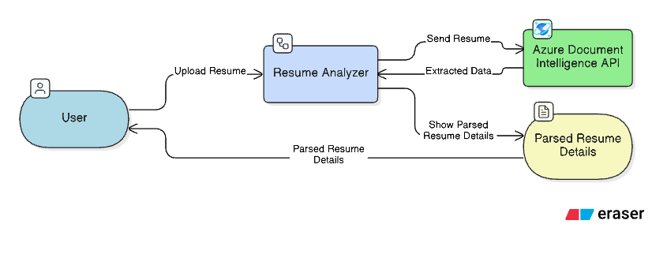

Annexure B
Entity-Relationship Diagram (ERD)
(Mandatory)

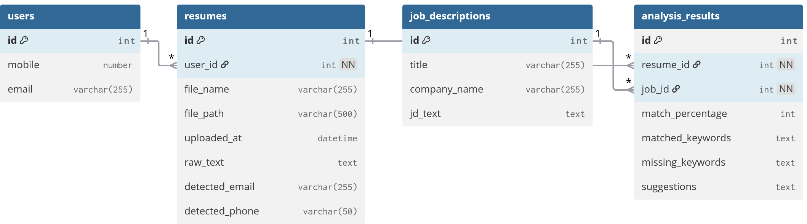
Annexure C
Use-Case Diagram (UCD)
(Optional)
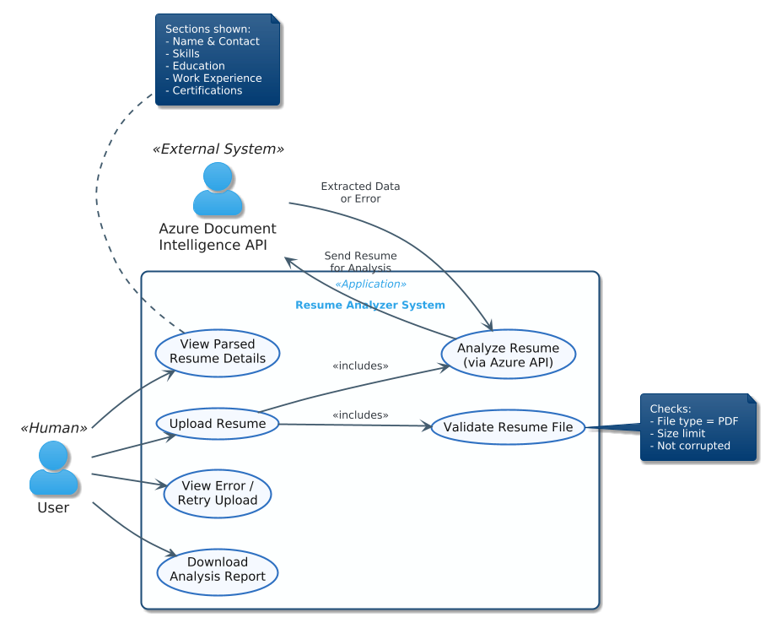
Annexure D
Data Dictionary (DD)
(Mandatory)

Resume Table (RESUME)

Fields | Data Type | Description
RESUME-ID | Number | Unique ID for each uploaded resume
RESUME-File-Name | Text | Name of the uploaded PDF file
RESUME-File-Path | Text | Storage path of the uploaded file

Analysis Result Table (RESULT)
Fields | Data Type | Description
RESULT-ID | Number | Unique analysis result ID
RESUME-ID | Number | Reference to Resume table
RESULT-Email | Number/Text | Extracted phone number
RESULT-Skills | Text | Extracted skillset
RESULT-Experience | Text | Extracted work experience

Annexure E
Screen Shots
Home Page:
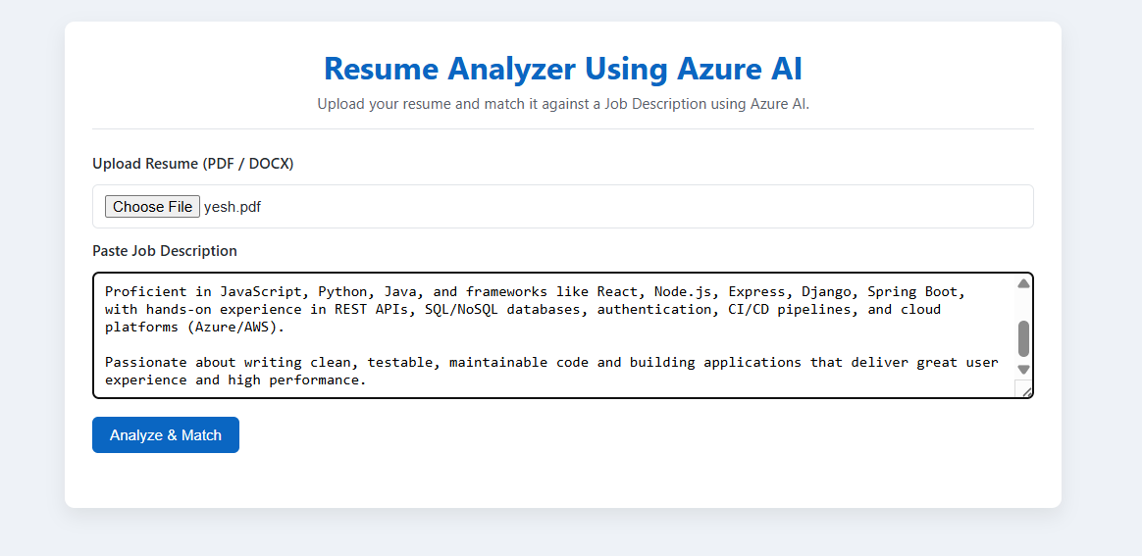
Analyze Page:
